PROJECT REPORT TEMPLATE

INTRODUCTION

1.1 OVERVIEW

The vehicle management system (VMS) is an application for the automative industry. It supports, in the area of sales& services , the business processes that you require as vehicle importer when dealing with your original equipment manufactures ( OEMs) and your dealers in new and used vehicle sales.

1.2 PURPOSE

A vehicle management system is a software system or platform that servers to , manage commercial fleets of vehicles , such such as cars , vans or trucks or even heavy equipment to ensure they’re utilized safely, efficiently and proffessionaly , while making sure they’re well maintained and high-performing .

2. PROBLEM DEFINITION AND DESIGN THINKING

2.3 EMPATHY MAP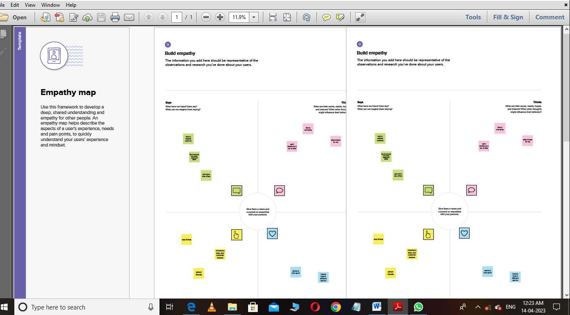

BRAIN STROAMING

|  |
| --- |
|  |

RESULT

3.1 DATA MODEL

|  |  |
| --- | --- |
| Object Name | Field in the object |
| Vehicle managements | |  |  | | --- | --- | | Field label | Data type | | Vehicle manager | Auto number | |

3.2 ACTIVITY AND SCREENSHOT 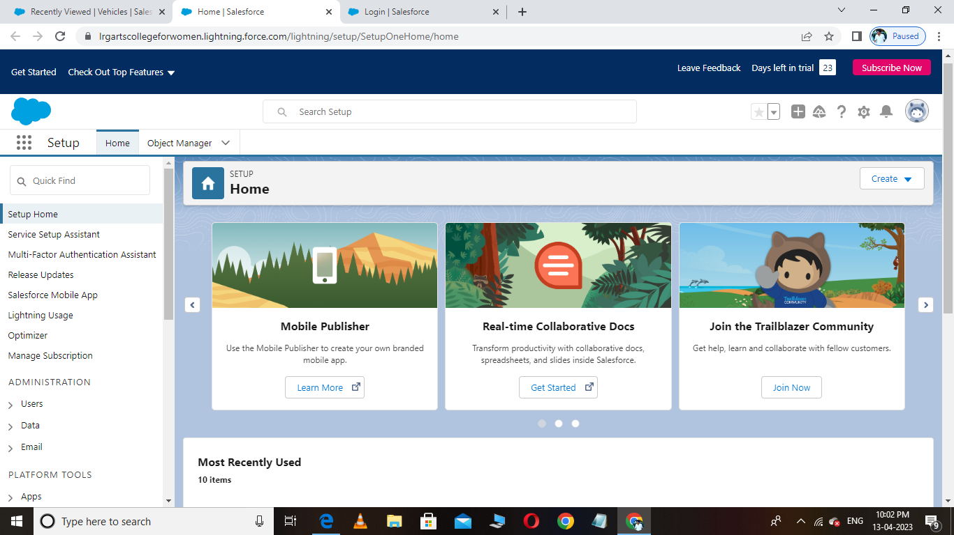

1. DEVELOPER ACCOUNT CREATE

|  |
| --- |
|  |

2. VEHICLE OBJECT CREATOR

|  |
| --- |
|  |

3. REPORT

|  |
| --- |
|  |

4. Trailhead profile public URL

Team Lead-: https://trailblazer.me/id/hp5168794

Team Member 1-https://trailblazer.me/id/mphysicca1

Team Member 2-https://trailblazer.me/id/sujis27

Team Member 3- https://trailblazer.me/id/ssush85

Team Member 4-https://trailblazer.me/id/ufathima5

PROJECT REPORT TEMPLATE

5. ADVANTAGES & DISADVANTAGES

* Schedule shifts and work hours.
* Track vehicles, assets or professional equipment.
* Schedule routine maintenance.

DISADVANTAGES:

* It requires skilled resource to maintain such system. This increases maintenance costs.
* GPS device used in fleet management is power hungry which drains battery faster.
* GPS signal does not pierce through the walls, solid structures, under water or dence trees.

6. APPLICATION:

Technologies such as Telematics are available to mitigate the risk not that outcome becoming a reality. Fleet management system are now readily available, using such technologies, to help businesses strategize their operations and coordinates the use of assets and workforce toward optimal performance and efficiency. Thus, improving their viability and growth.

7.CONCLUSIONS:

The fundamental problem involved in evaluating proposals for changes in truck dimensions is that their effects can often only be estimated or modelled.

8. FUTURE SCOPE

* Fleet vehicle tracking
* Alerts & notifications
* Health alerts
* Alerts for unexpected events
* Driver behaviour notifications and metrics
* Fuel managements
* Trip log and mileage
* Vehicle maintenance